Lab 11
Configuring VOIP Using Cisco Call Manager Express
In Packet Tracer

Preliminary Discussion
In the Cisco world for organizations with 450 or fewer endpoints, such as IP phones, the suggested method to use to implement VOIP is Call Manager Express. This is a set of telephony functions built into the router's IOS on several of the ISR routers designed for small and medium sized organizations, as well as the branch offices of larger organizations. Most routers are sold with the most basic version of the IOS which is IP Base. VOIP requires that the IOS be changed to the IP Voice version which is one step up from IP Base.
Network Layout

Here is the network that will be created to begin this lab. Create the layout in Packet Tracer. The router is a 2811. The switch is the Multilayer Switch. The only reason the Multilayer Switch is being used is that it is the only one in Packet Tracer that supports POE. If another switch type is used the IP Phones will need to have their power connector attached. The IP Phone is under End Devices.
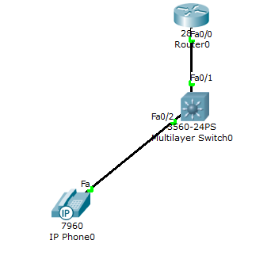
The router connects to the Fa0/1 port on the switch. The first IP Phone connecst to Fa0/2.

Instructions for Configuring the Devices - The First Three Devices
To allow VOIP calls to proceed through the network the IP telephony functions of the devices must be enabled as they are off by default. Let's look at the configuration of each device. The configurations are shown with comments for the commands you have not seen before:
First the router in the left building.
!Left Building Router
enable
config t
hostname LeftBuildingRouter
!In this case the router will act as the DHCP server for the IP Phones. These four commands create the pool.
ip dhcp pool Left
network 192.168.1.0 255.255.255.0
default-router 192.168.1.1
option 150 ip 192.168.1.1
int fa0/0
ip address 192.168.1.1 255.255.255.0
no shut
exit
!The telephony services are off by default. This command turns them on.
telephony-service
!The next two commands do not have to be used, but they commonly are.
!The max-ephones command limits the number of phones that can be used. This is to reduce the load on the router.
max-ephones 5
!The max-dn command limits the number of directory entries that can be used. This is to reduce the load on the router.
max-dn 5
!This command tells the phones the IP address they will talk to. The port is 2000 by default but Packet Tracer appears to require it be stated
ip source-address 192.168.1.1 port 2000
!This command assigns extension numbers to the phone buttons.
auto assign 1 to 5
exit
!These two commands assign an extension number to the first phone and then the second phone.
!The ephone-dn command without any arguments creates virtual voice ports. In this case one port is created. So one call to or from this phone is all that is allowed. The dual-line argument would create two virtual ports for a dual line phone.
ephone-dn 1
number 101
ephone-dn 2
number 102
end
Next is the switch. Here is its configuration:
!Left Building Switch
enable
config t
int range fa0/1-5
!This command sets the ports shown above to carry voice traffic.
switchport voice vlan 1
end
You must connect the phones to one of these ports.
Last is the first IP Phone. If the Multilayer Switch is not used in Packet Tracer for it to work the power adaptor must be added to it this way.
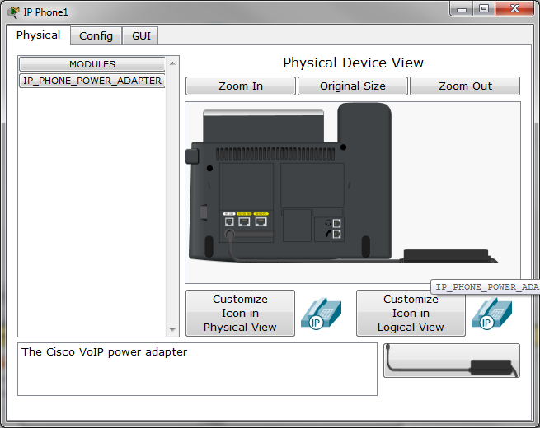
To ensure the above configurations worked the first check is to see if the IP phone received an IP address and a line number from the router. Hover the cursor over the phone to see if it did. It takes a while for this to appear. It looks like this:
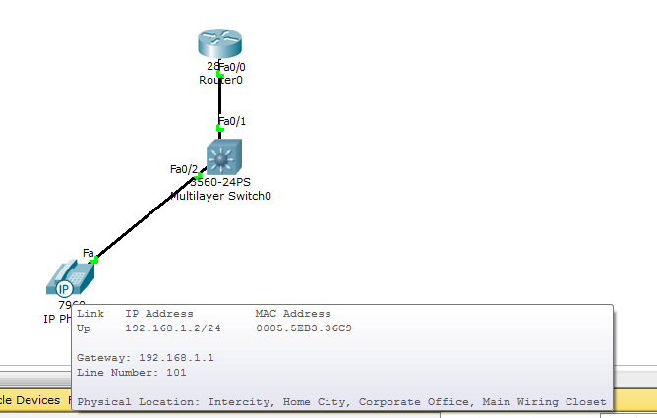

Instructions for Configuring the Devices - Adding a Second IP Phone
Once the basic setup works a second phone must be added so that the first phone will have someone to talk to. The setup for the second phone is already in the router. Add it, connect it to port Fa0/3, and then hover over this phone to be sure it receives an IP address and a line number.

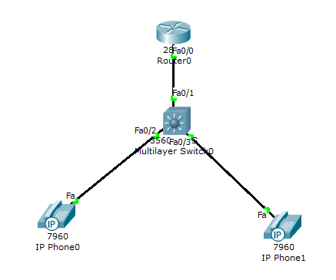

Instructions for Calling Between Phones
Let's see if this all works. Call the second phone from the first phone this way:
Click on the first phone. Click on the GUI tab. The phone will look like this:
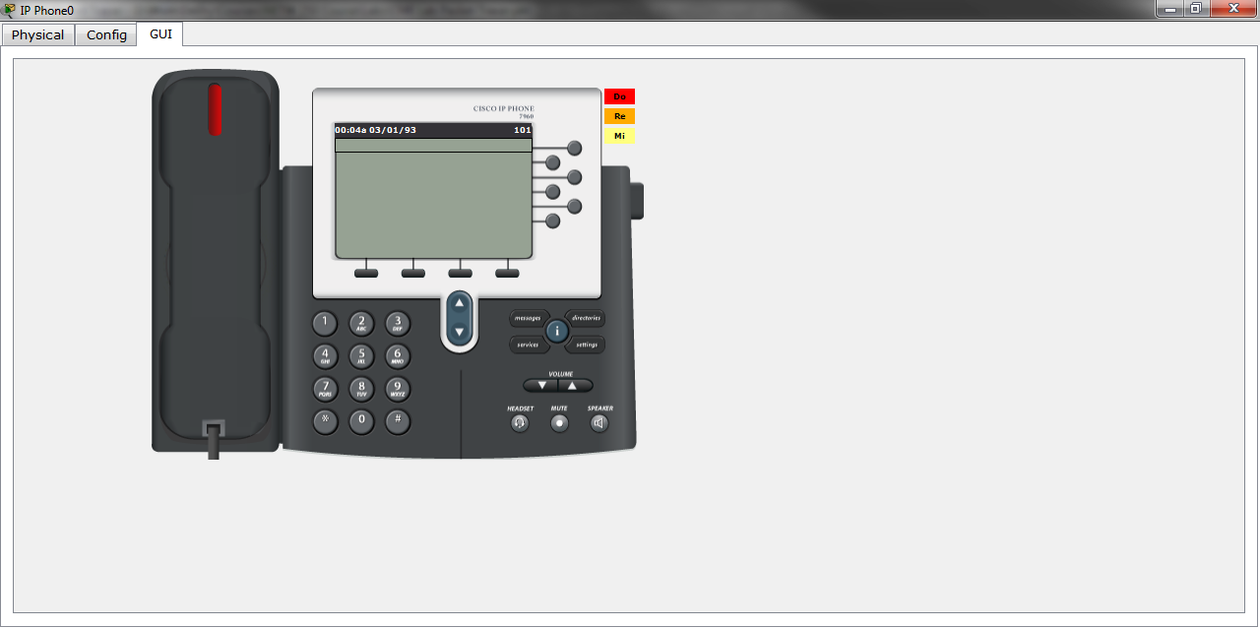
Dial the second phone by clicking on the 1 0 2 numbers. Then click the handset. If sound is enabled you will hear the call dialed and ringing.
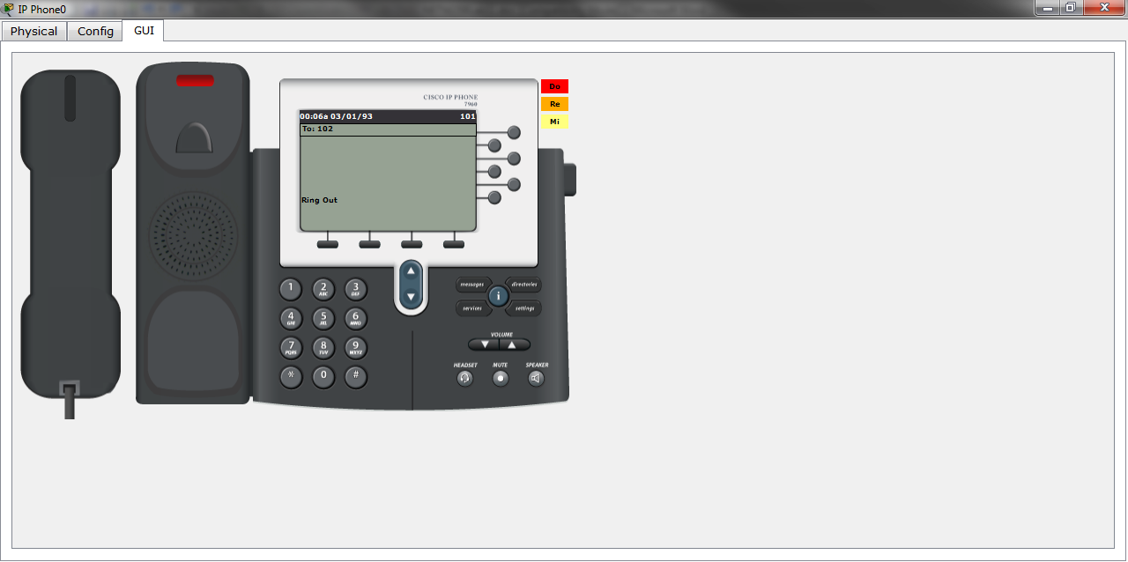
Now click on the second phone. Notice that it is ringing.
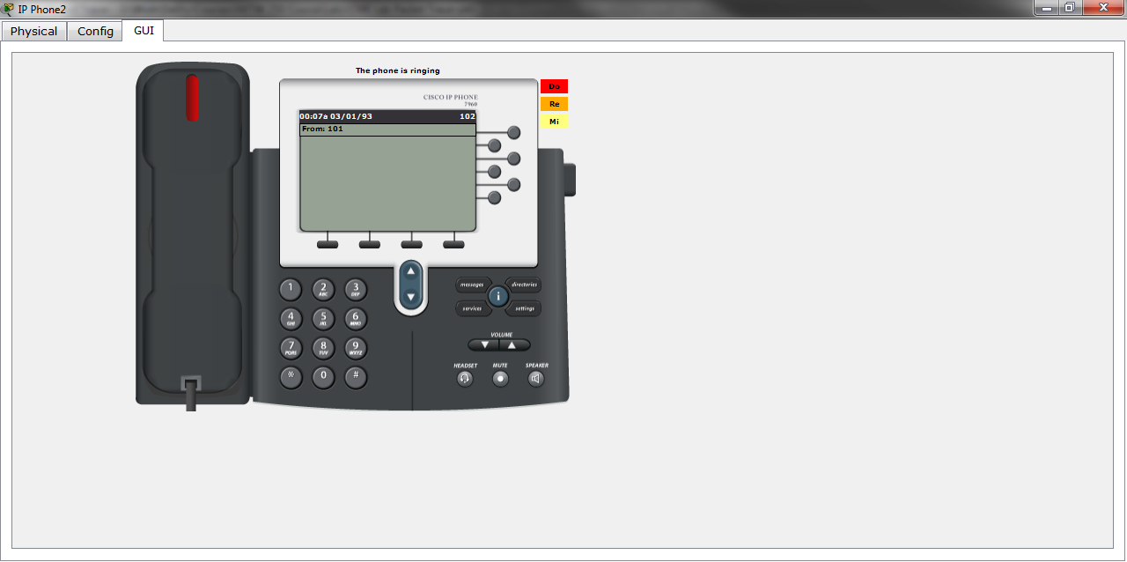
Answer it by clicking on the handset.
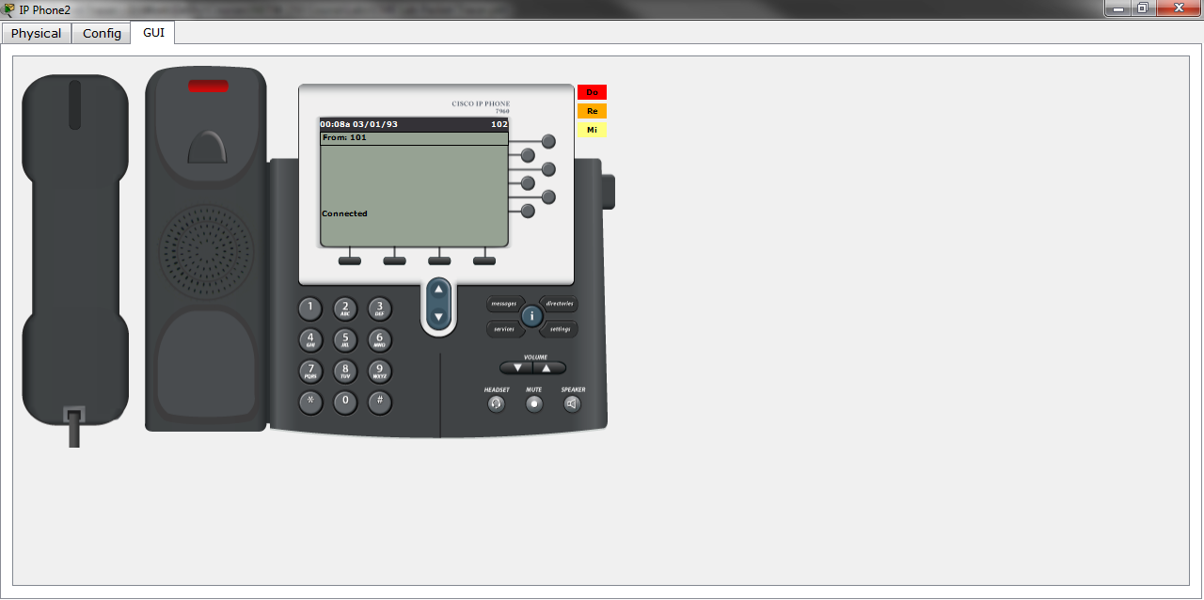
Hang up both phones by clicking on the handset again.
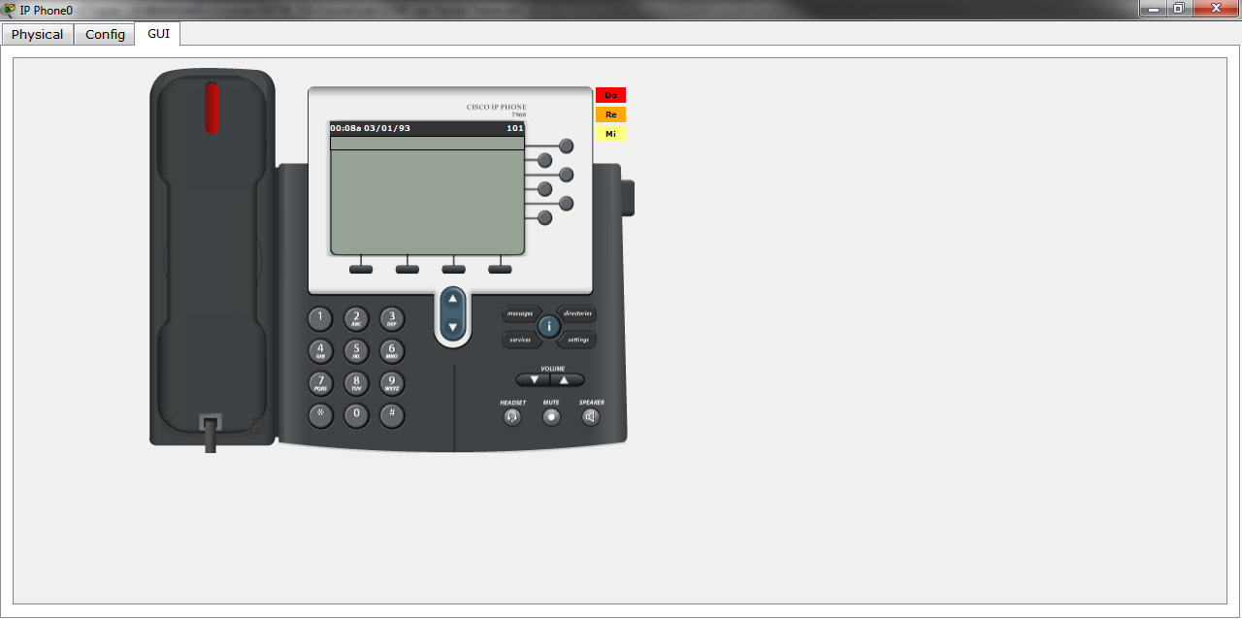

Instructions for Adding a Second Location
Let's add a second location to see if we can call across a larger area such as a CAN, MAN, or WAN. Add a second location that looks like this:
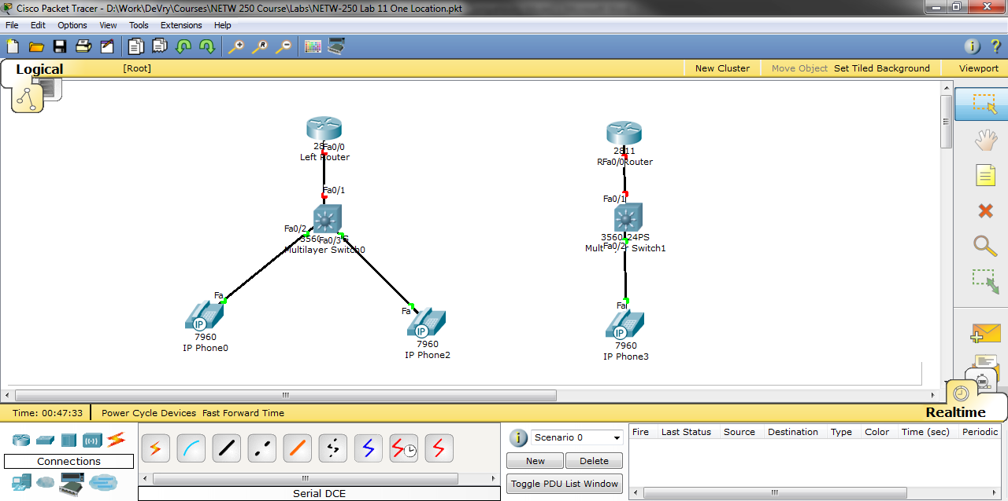
A serial card must be added to the two routers. Put a WIC1T in this slot in both routers.
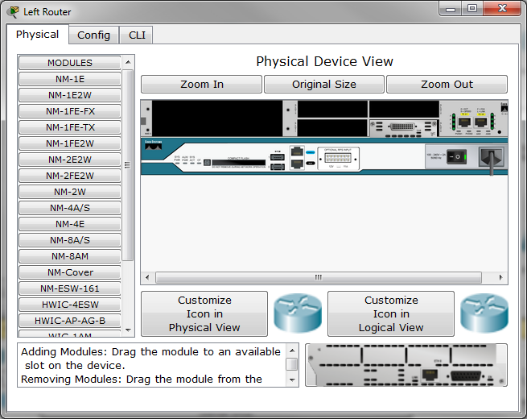
Connect the two routers to each other with the Left Router being the DCE device.
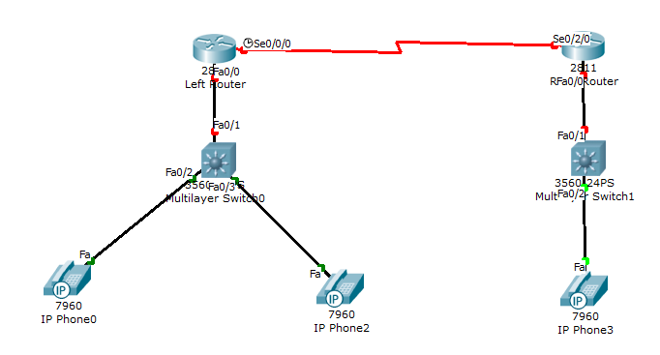
Here is the revised configuration for the Left Router.
!Left Building Router Two Locations
enable
config t
hostname LeftBuildingRouter
ip dhcp pool Left
network 192.168.1.0 255.255.255.0
default-router 192.168.1.1
option 150 ip 192.168.1.1
int fa0/0
ip address 192.168.1.1 255.255.255.0
no shut
int s0/0/0
ip address 192.168.2.1 255.255.255.0
no shut
clock rate 64000
exit
ip route 192.168.3.0 255.255.255.0 s0/0/0
telephony-service
max-ephones 5
max-dn 5
ip source-address 192.168.1.1 port 2000
auto assign 1 to 5
exit
ephone-dn 1
number 101
ephone-dn 2
number 102
!Allow one location to talk to the other location
dial-peer voice 1 voip
destination-pattern 2..
session target ipv4:192.168.2.2
end
And for the Right Router
!Right Building Router Two Locations
enable
config t
hostname RightBuildingRouter
ip dhcp pool Right
network 192.168.3.0 255.255.255.0
default-router 192.168.3.1
option 150 ip 192.168.3.1
int fa0/0
ip address 192.168.3.1 255.255.255.0
no shut
int s0/0/0
ip address 192.168.2.2 255.255.255.0
no shut
exit
ip route 192.168.1.0 255.255.255.0 s0/0/0
telephony-service
max-ephones 5
max-dn 5
ip source-address 192.168.3.1 port 2000
auto assign 1 to 5
exit
ephone-dn 1
number 201
!Allow one location to talk to the other location
dial-peer voice 1 voip
destination-pattern 1..
session target ipv4:192.168.2.1
end
And the Right Switch
!Right Building Switch
enable
config t
hostname RightSwitch
int range fa0/1-5
switchport voice vlan 1
end

Instructions for Calling Between Locations
Let's see if this all works. Call the 201 extension from the 101 extension as done above.
Source
This lab is from an unidentified lab found while searching for CME Packet Tracer labs. The origin is unknown.
Replicating This Lab on a Cisco Router
To do this lab on physical equipment in Room 227 the following is required:
Cisco 2600 series router with the label that says - New Security/QoS IOS
9-14-2009

