Lab 1
Installation of Debian Linux From an ISO File Into an
Oracle VirtualBox Virtual Machine

Preliminary Discussion
We will be using and open source PBX application in this course in order to see how VOIP functions. This application has been written to run on the Linux operating system. Although it will run on several different distributions of Linux, we will be installing the command line version of the Debian Linux operating system as the basis for our PBX installation. For convenience sake and equipment efficiency, we will be performing our installation on a virtual machine. Because you will be sharing these computers with students of other courses, it would be an excellent idea for you to backup your VMs to a flash drive at the end of each class.

Things you need for the installation
- A computer on which to install Debian Linux
- A functioning network connection
- A functioning DHCP server on the network
- Broadband Internet access
- Debian installation ISO file
- VirtualBox

Preparations
- The first part of the experiment is the creation of a new virtual machine in which to install the Linux operating system.
- Next, we will be installing Debian from an ISO installation disk that we will retrieve from the Debian.org website. Note that because of version modifications to the Debian Linux, what you see on the screen may vary slightly from the screen shots depicted in this lab.

Retrieving a copy of Debian Linux Installation Image
- In order to perform our installation of Debian Linux we will need to download an ISO image file from the Debian. org website. Open a browser and navigate to Debian.org.
- At the top of their home page you click on the “Getting Debian” link.
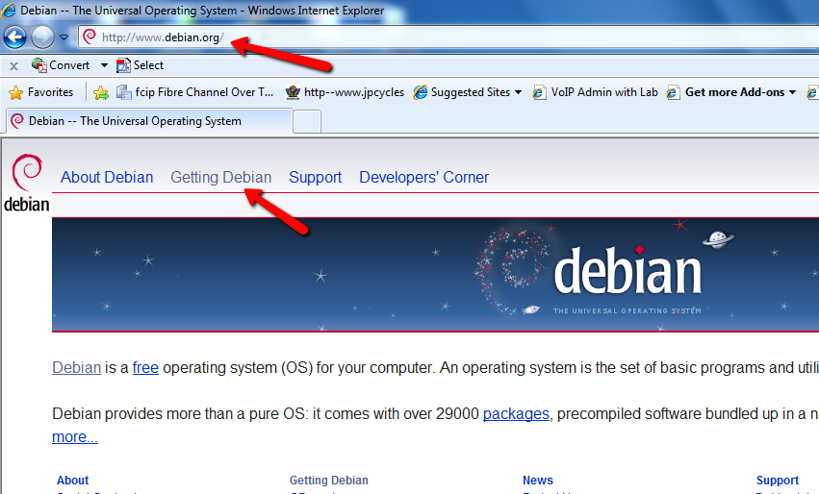
- Scroll down the new page until you see a link that says, “Download a small installation image.” Click on it.
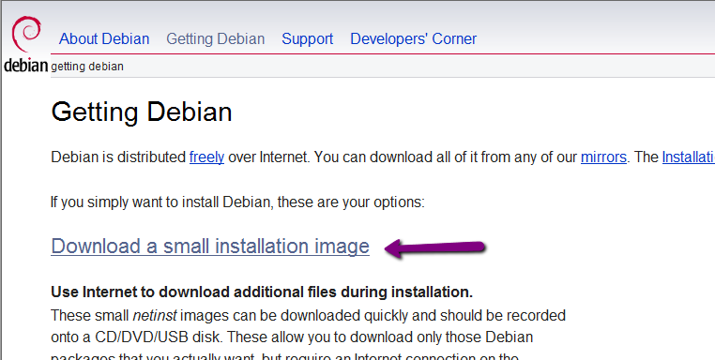
- You will see two options - Small CDs and Tiny CDs, USB sticks, etc. Look below the Tiny CDs, USB sticks, etc. heading for the i386 image. This is the image that we need to install on an Intel processor based computer that we have here at DeVry. In the off chance that your computer has a different processor, you will need to download a different image. All of the download names are jammed tightly together, so be sure that you select the correct one.
- When you select the proper file save it to drive E: of your lab computer’s hard drive.
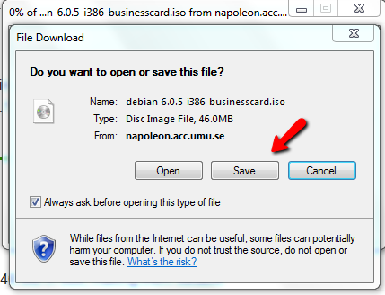
- Be sure to remember where you saved your copy because you will need it to perform your Linux installation. When the copy process has concluded, begin the process of creating your VM.

The VirtualBox installation process
- Locate the VirtualBox icon on the Windows desktop as show in the figure.
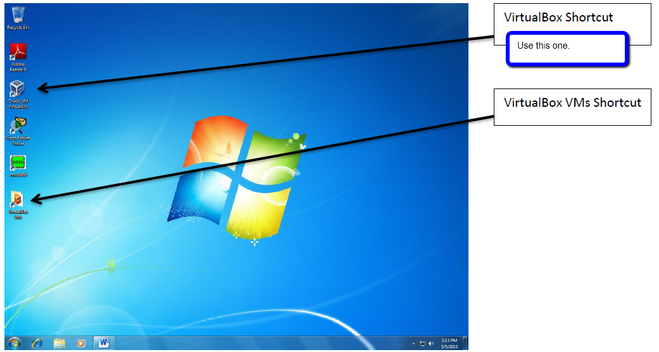
- After VirtualBox has started, click the New button on the menu bar to create a new virtual machine.
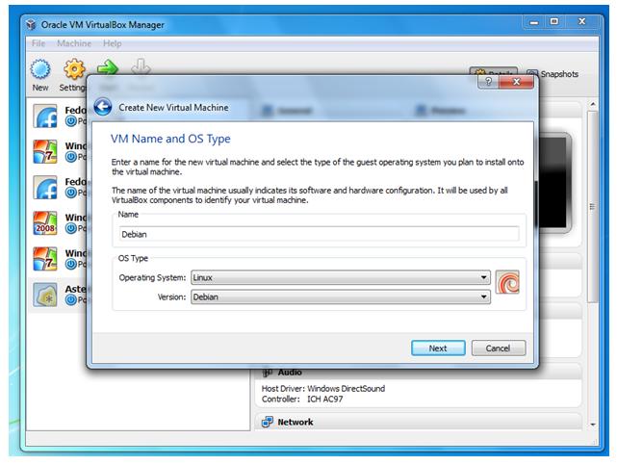

- Name the new virtual machine Debian_{Your Last Name}, use the drop down select and choose Linux and Debian as the version and then press, Next” Note. This only prepares the virtual machine for the installation of the operating system. It is not the installation process itself.
- In all cases unless directed otherwise use the default settings, such as when presented with the option for the location of the virtual drive, take the defaults of Create new hard disk, as seen below.
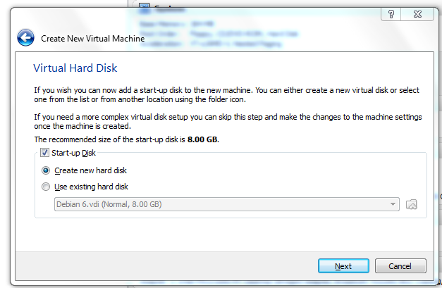
- Once again just take the defaults when presented with the next screens as seen below.
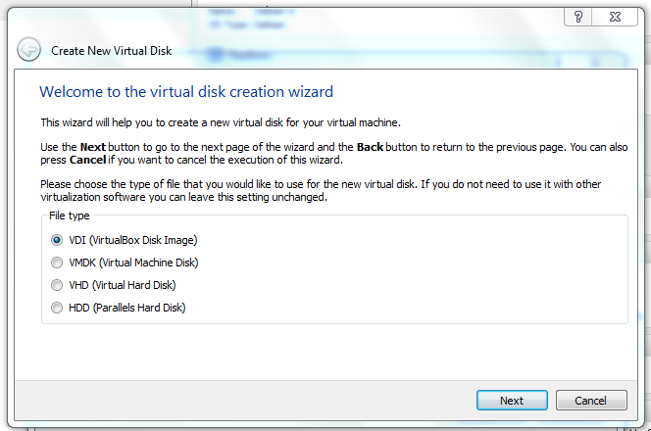
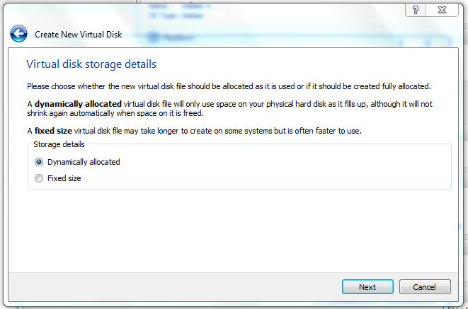
- When you are presented with the next screen use the small folder icon on the right side of the screen to navigate to the location where the ISO file is stored. Leave the disk size as the default.
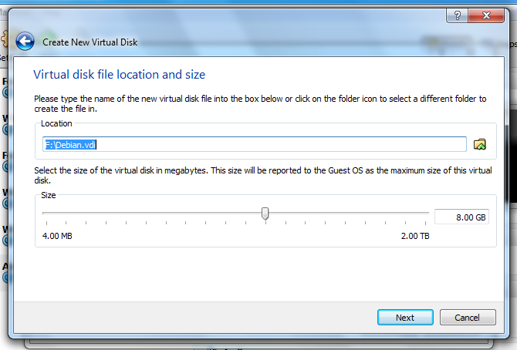
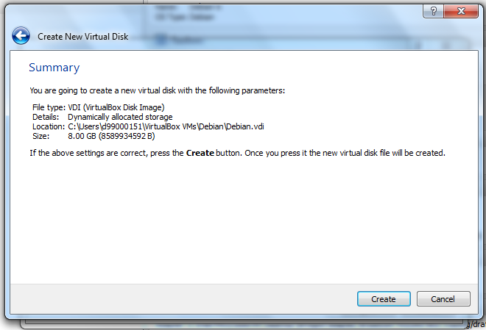

- Finally you will be provided with a summary of the selections that you have made. Press the Create button to confirm the creation process.

Time to Install the Debian Linux Operating System
- Make sure that the newly created virtual machine is highlighted when you click the Start button from the manager window and you will be presented with the screen below.
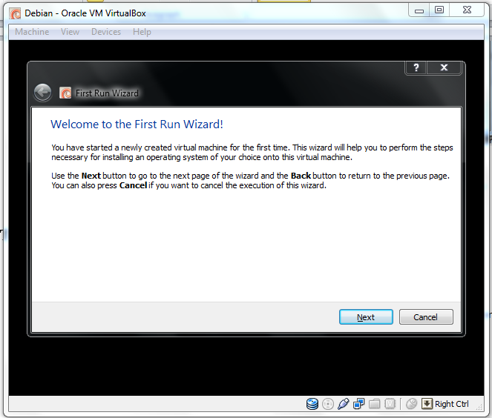
- When you click the Next button you will be presented with options for the location of the installation disk. Click the little folder icon on the right side of the Media Source window and navigate to where the Debian installation ISO file is located and then click Next to begin the process.
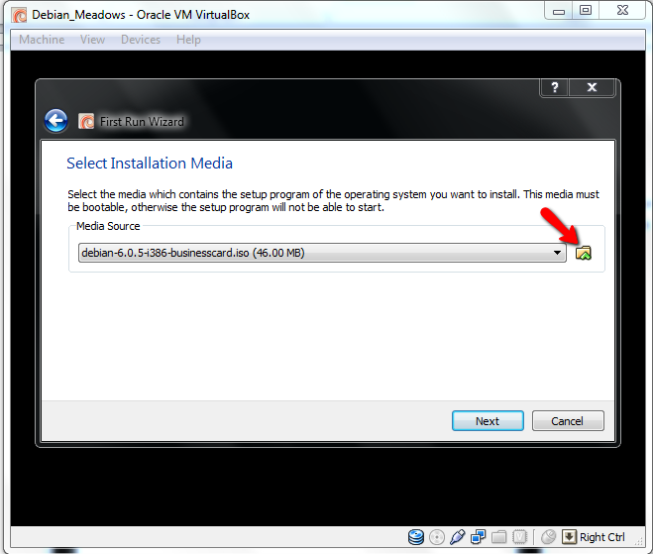
- You will then be presented with a summary of your choices. Click the Start button to boot from the ISO image.
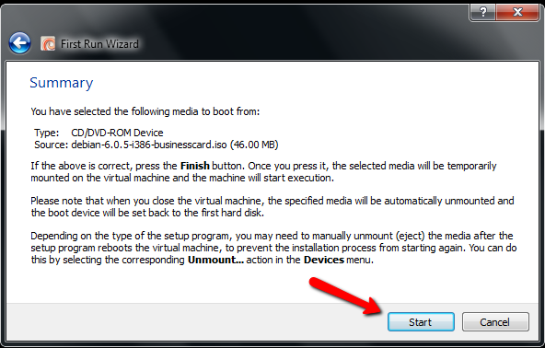
- When the computer boots from the CD, you should see something similar to the following screen.
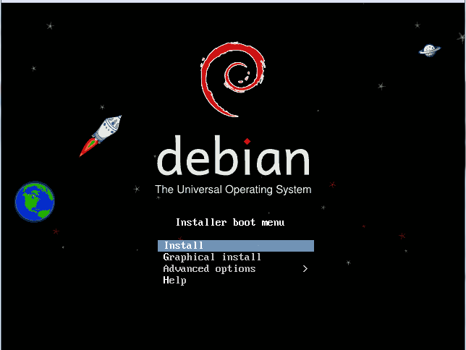
If your screen doesn’t look like this, it is probably because the computer didn’t boot from the image.
- Choose the Install option and press Enter.
Now the Linux kernel and the initial ramdisk are loaded, wait until you can see the language selection screen.
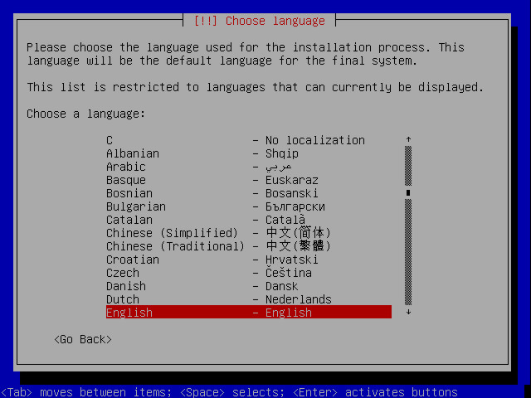
- You should choose English here and press Enter.
- Select your country in the following list.
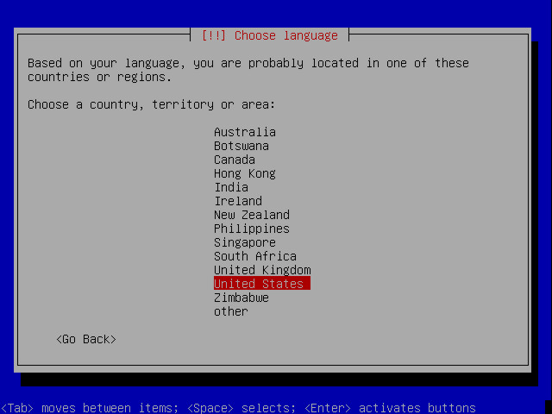
- Select your Keyboard layout in the following list and press Enter.
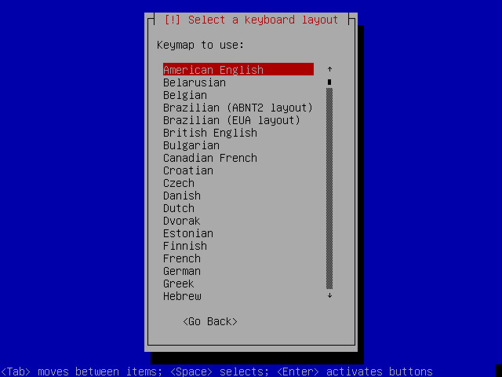
- Now several progress bars appear that show loading of drivers and components needed for installation, searching for DHCP server, and configuring network access.
- Next you will be asked for a hostname of this machine. DO NOT enter the domain name here. Your fully qualified hostname will be your _last_name.example.com, so you need to enter only your last name here. NOT Devry-1 as shown in the example and press Enter.
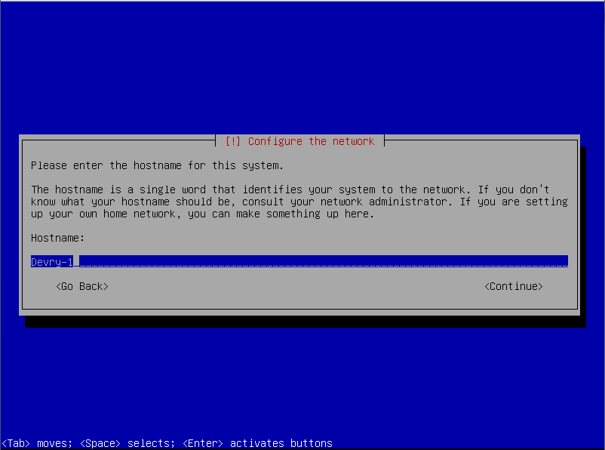
- In the next page enter the domain name - use example like in the figure - and press Enter.
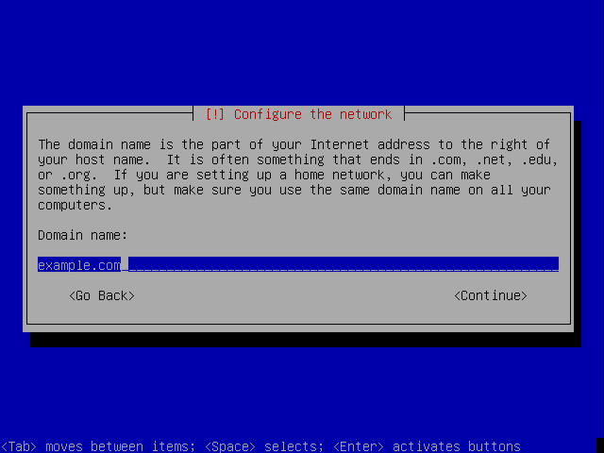
This next step on mirror selection may appear here or it may not appear until later. If it does not appear here, just skip down to the first section that you do see.
- Now you are asked to select a Debian mirror server location, where the latest versions of the software packages are downloaded from, with the United States is a good choice.
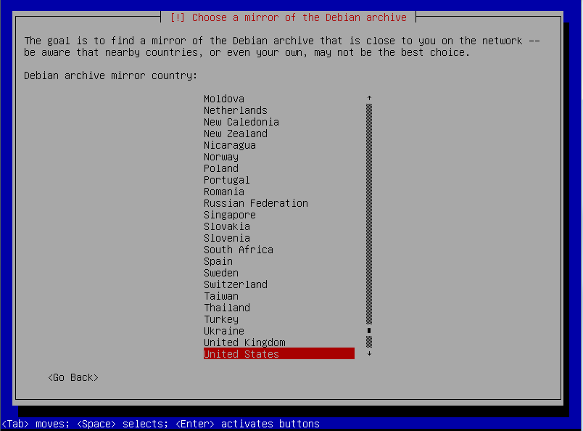
- Select the mirror location next to you and press Enter.
- There is more than one mirror in the United States so you will have to select a particular one. I’m not sure if one is any better than another, so just pick one that appears to be the closest.
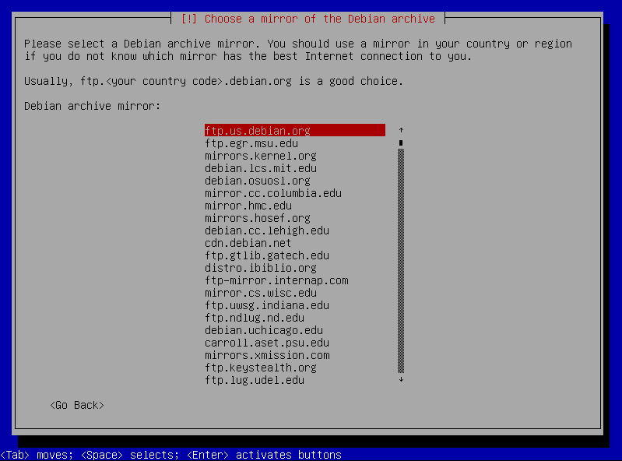
- If you need a proxy server to access the internet, you can add the information here. We don’t, so just leave it blank.
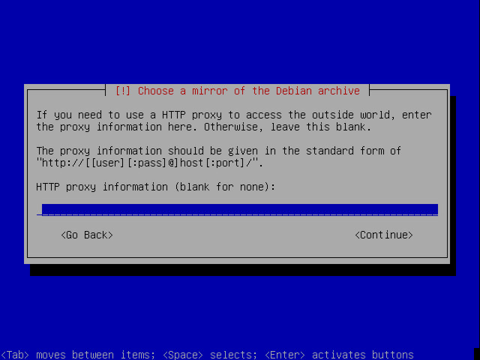
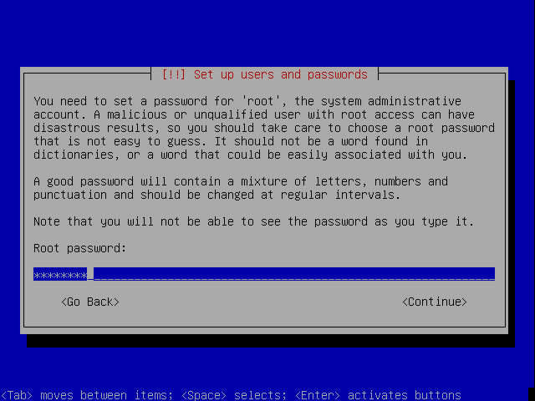
- Enter your root password and press Enter. DO NOT FORGET THE ROOT PASSWORD. I would recommend that you use password.

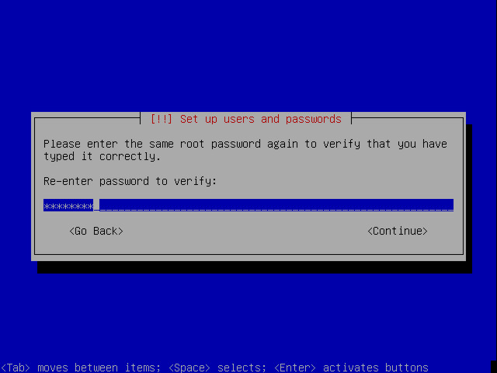
- Enter your root password again to confirm and press Enter again.
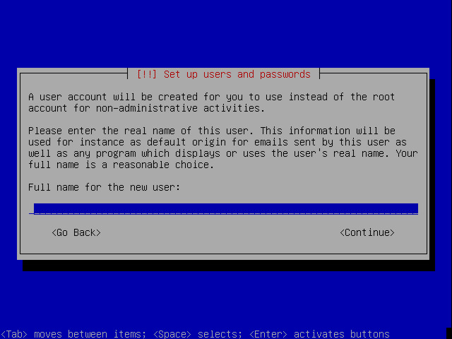
- You are now forced to create a user by entering a name. Use your first name as the account and press Enter.
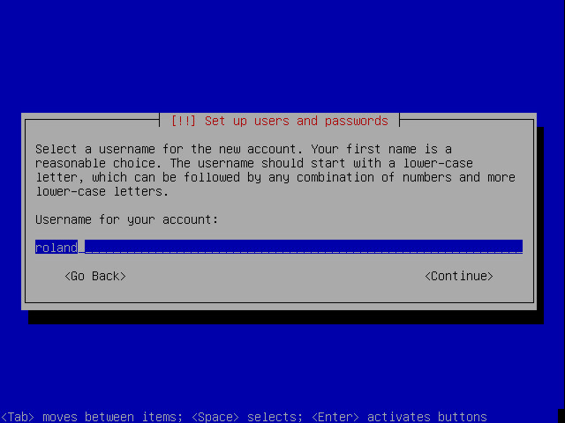
- You MUST specify a login name for the new user. It will default to the Full Name that you entered in the previous screen. Enter a suitable username or take the default and hit Enter.
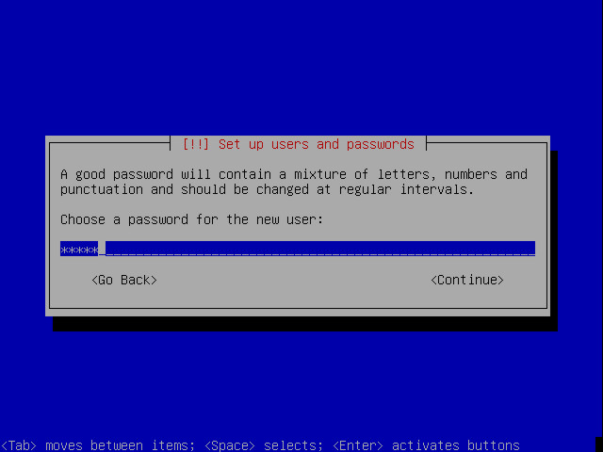
- Of course, our new user needs a password too, so enter a password and hit Enter. DON’T FORGET YOUR PASSWORD. Again, I would recommend that you use password.
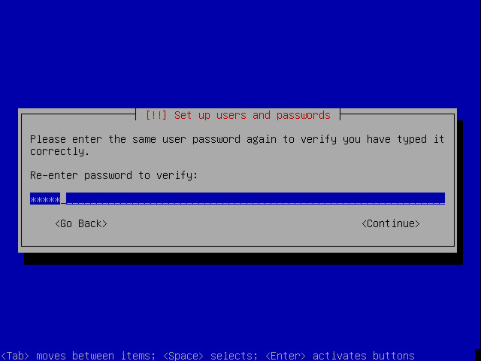
- Please enter the user's password again for confirmation and hit Enter again. Now you will see some more of the setup occur.
- When you are prompted to set the time, be sure to choose Central for the zone.
The next screens show you the installer loading everything necessary for starting the harddisk partitioning, wait until you see the following screen.
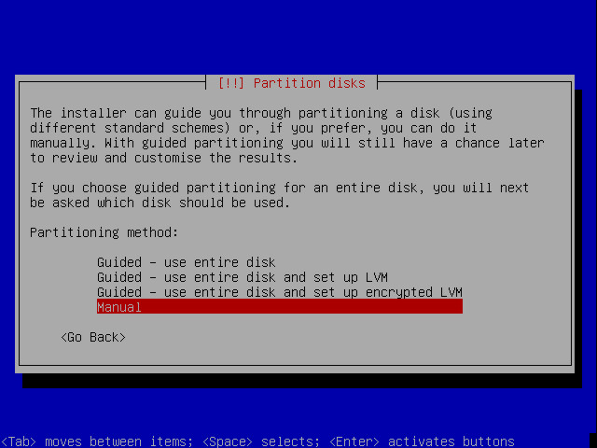
- Select Manual unless you know what you are doing and press Enter.
- If you use a brand new harddisk, without any partitions on it, the next screen looks like this.
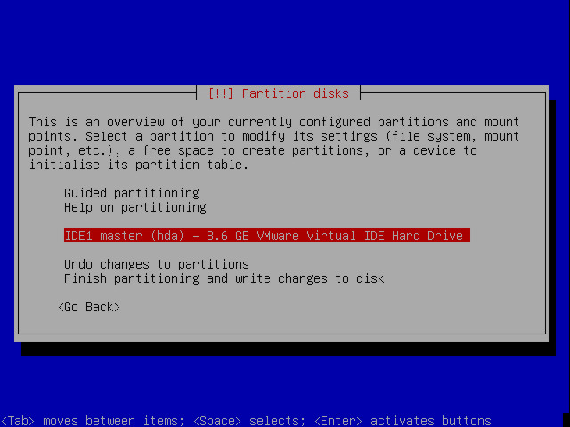

- First we need to create an empty partition table. Do this by selecting the harddisk like it is shown in the above screenshot and press Enter, then the following screen appears.
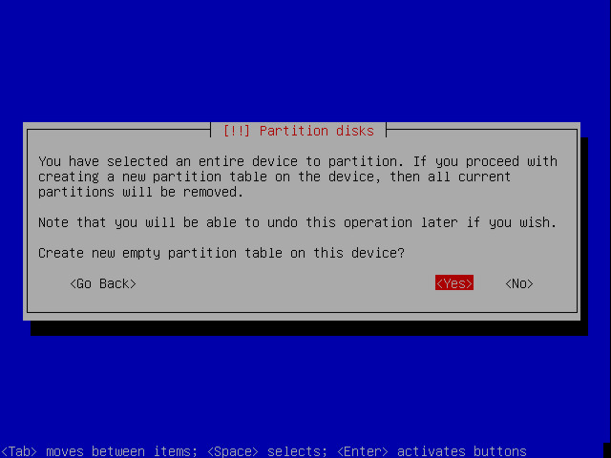
- Confirm the creation of an empty partition table by selecting Yes and press Enter, which brings us to the following screen.
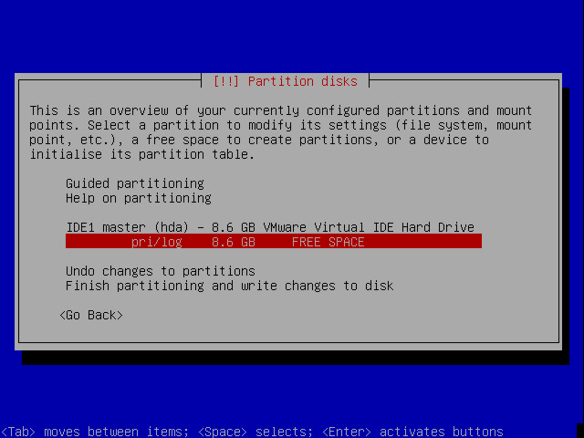
- We are going to create 4 primary partitions on the drive.
The name as shown in column one just below does not matter. Whatever appears is fine.
name | mount-point | Size | filesystem
/dev/hda1 | /boot | 50MB | Ext3 (set the boot flag)
/dev/hda2 | <swap> | 512MB | swap
/dev/hda3 | / | 2GB | Ext3
/dev/hda4 | /var | the remaining space | Ext3
- Select the line that shows the words FREE SPACE and press the Enter key.
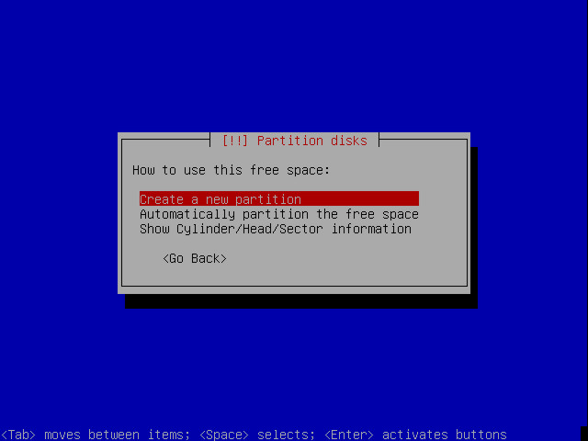
- Select Create a new partition and hit Enter.
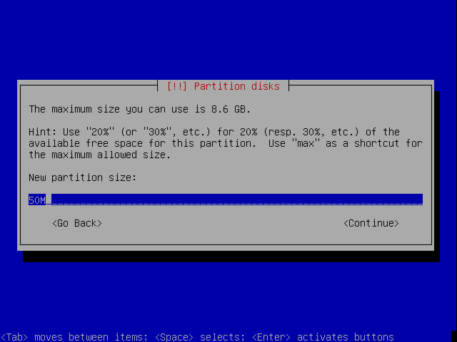
- Enter the partition size for our first partition which will contain all our static boot files like the kernel and the configuration for the grub bootloader, then press Enter.
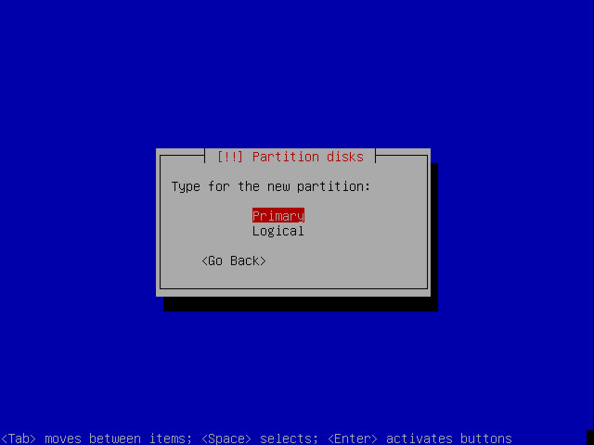
- Select Primary to create the partition as primary and hit Enter.
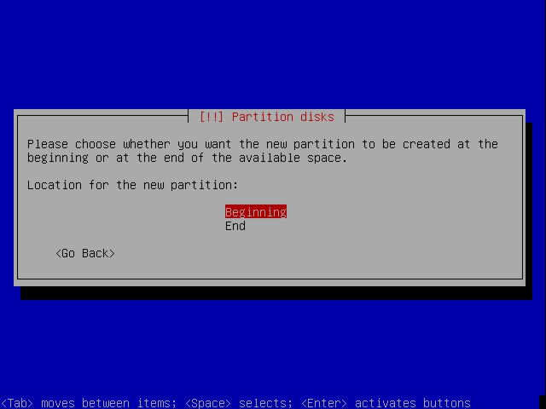
- We want to create the partition at the beginning of the free space, so please select Beginning and hit Enter.
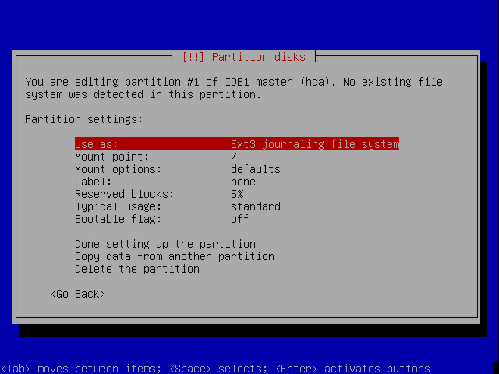
- The partitioning tool sets some defaults for the partition that are not the ones we would like to set, so we need to change some of them. You can do this by selecting the line with the property and select the suitable selection from a list. Let's begin with the filesystem. Please select the line that says Use as: and hit Enter.
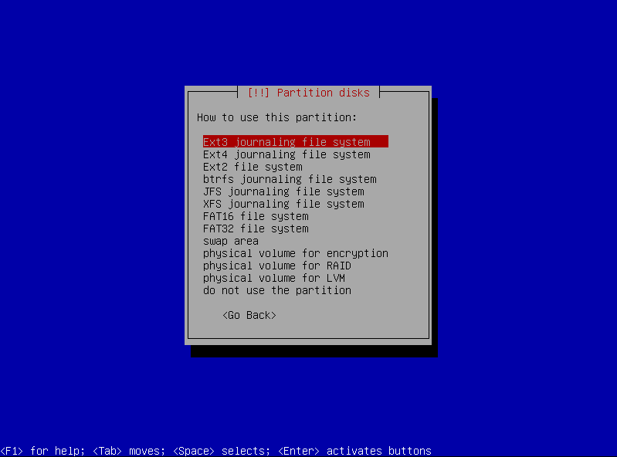
- Select the specified file system from the list shown in this screen. This will be ext3 for all of our partitions except for the swap partition, and then hit Enter.
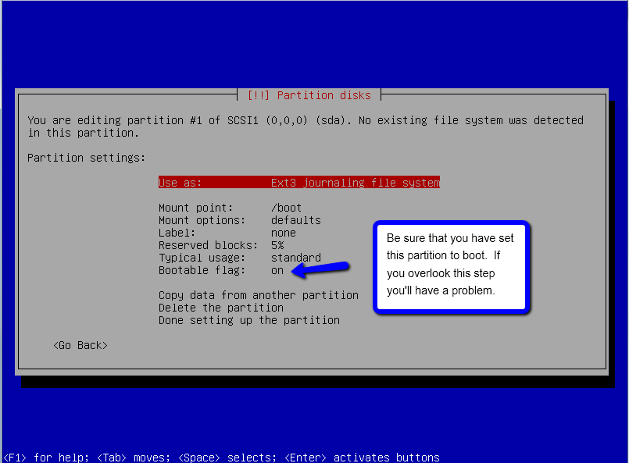
- When you have chosen the file type and mount point, select Done setting up the partition and hit Enter. to save the settings for our first partition
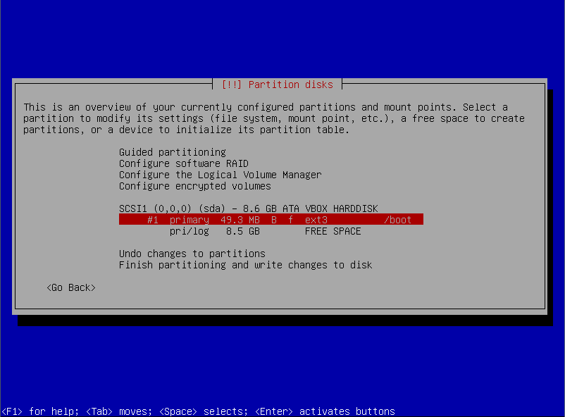

- Repeat the partition creation process by selecting FREE SPACE and creating each of the remaining three partitions as listed here.
name | mount-point | Size | filesystem
/dev/hda1 | /boot | 50MB | Ext3 (set the boot flag)
/dev/hda2 | <swap> | 512MB | swap
/dev/hda3 | / | 2GB | Ext3
/dev/hda4 | /var | the remaining space | Ext3
Notice that there is no mount point for a swap partition, just a file type. The swap partition is an area on the harddrive that is swapped out with memory to create a virtual memory system.
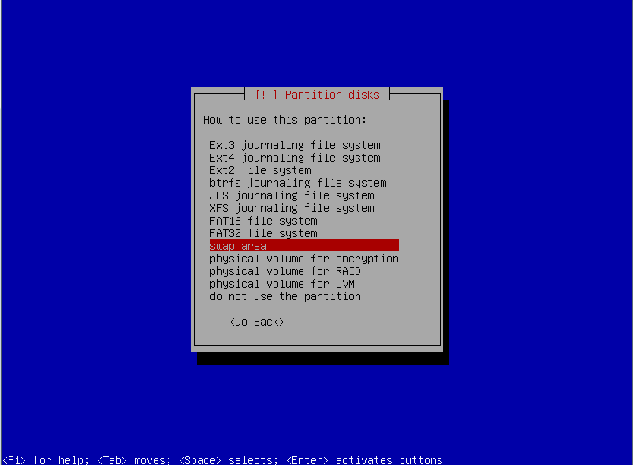
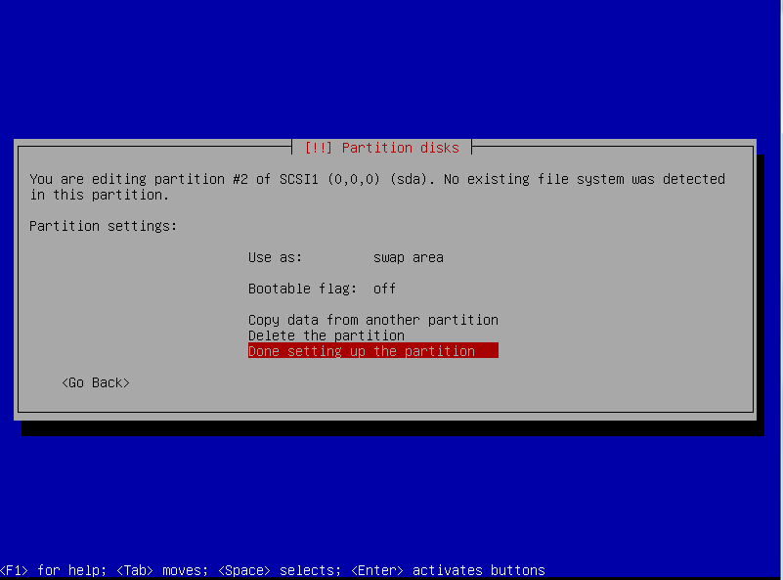

- The final partition layout should show something that is very similar to the following screen. As long as the sizes are close, that is ok. They do not have to be exact. Check these to be sure before they are written to the harddisk.
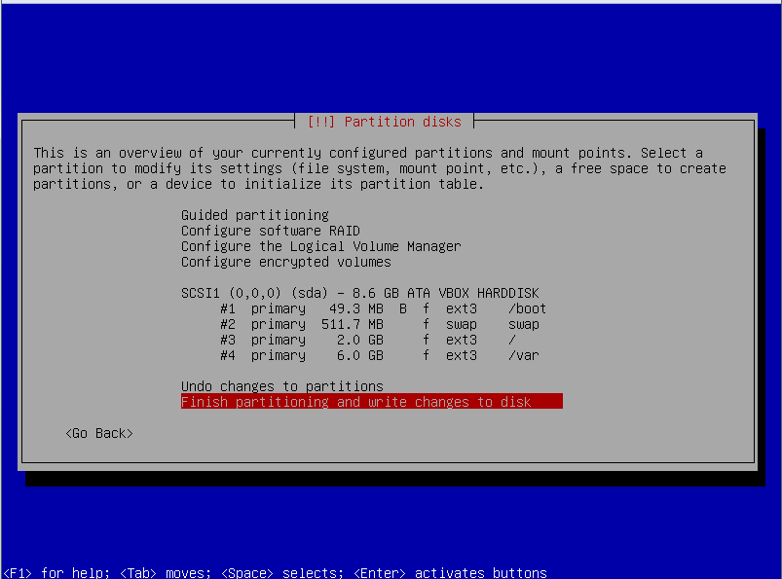
- Now that we have finished the partitioning, it is time to create the partitions. Please select the line Finish partitioning and write changes to disk and hit Enter.
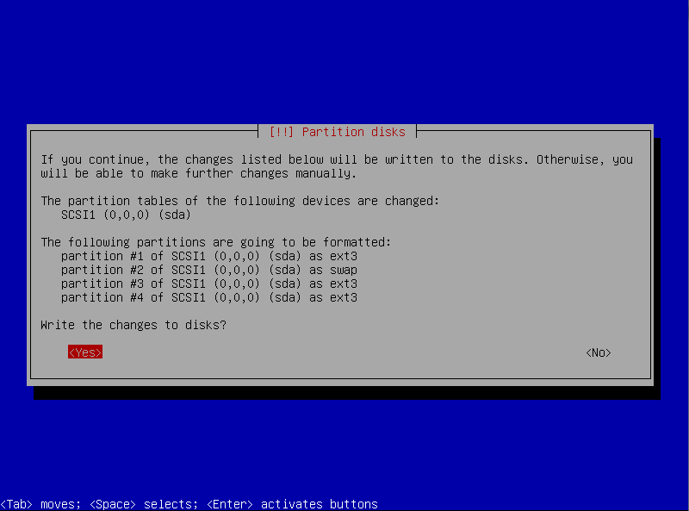
- Confirm the changes to be written to the harddisk by selecting Yes and hitting Enter.
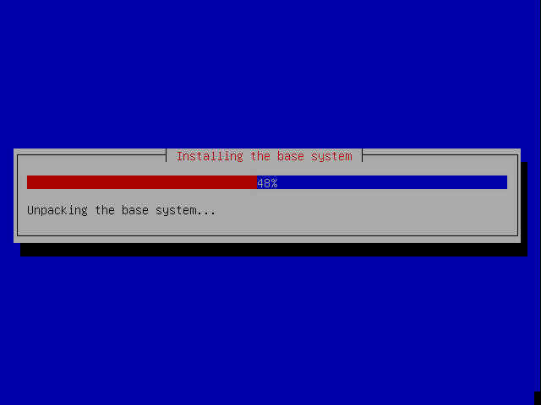
The mirror site selection section may appear here. If it does refer back to the section on this above, and then continue on as below.
- Now the base software packages are downloaded from the Debian mirror you selected previously and installed to the hard disk. Depending on the Internet speed and the hardware you are using this can take a while.
- After the installation of the base software packages you are asked to join the popularity contest. This helps the developers of Debian ISO images to put the mostly needed software packages to the first installation media.

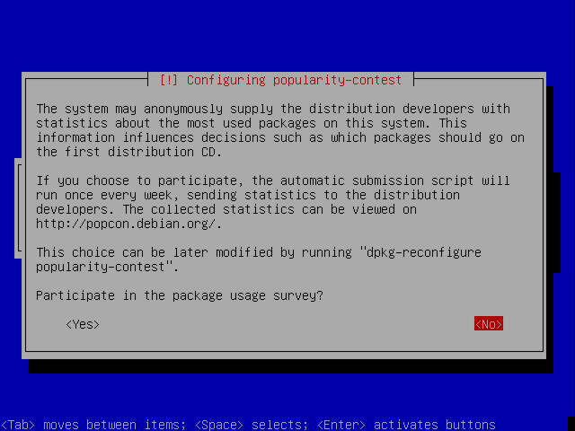
- Decline to join this contest by selecting No and hit Enter. A little more installing and configuring occurs…
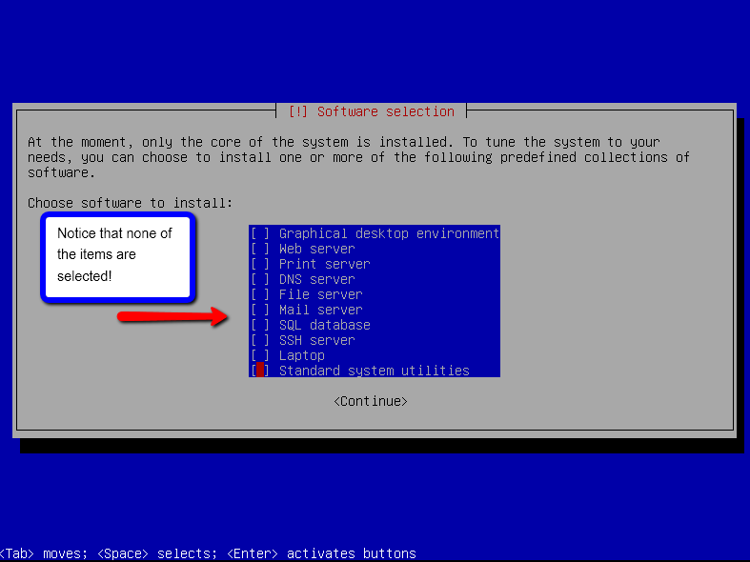
- Now it would be time for additional software to be selected and installed. By default the Standard system item is selected and we don’t want any of the extra packages installed. De-select it by using the arrow key to move the cursor over the * in the square bracket next to Standard System and pressing the space bar followed by the Enter key.
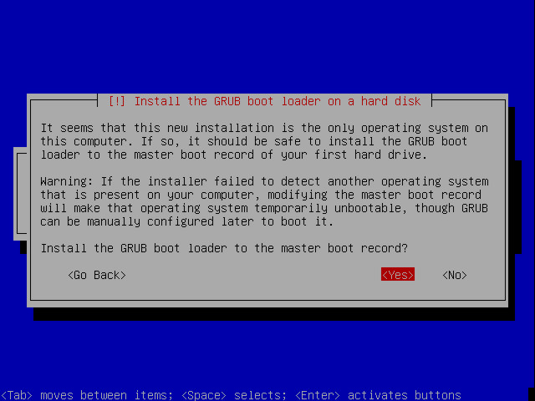
- The last option we have to confirm is to install the grub boot loader to the master boot record of our hard disk. Please select Yes and hit Enter.
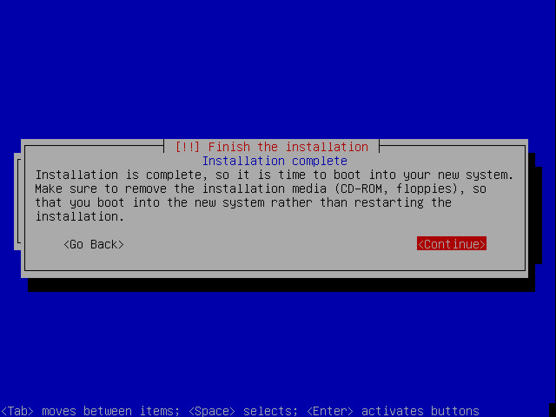
- Finally we have completed the installation and the installer now asks us to remove the CD from the drive and to reboot into the fresh installed system by selecting Continue and hitting Enter. Since we didn’t use a CD, there is, of course, nothing to remove.
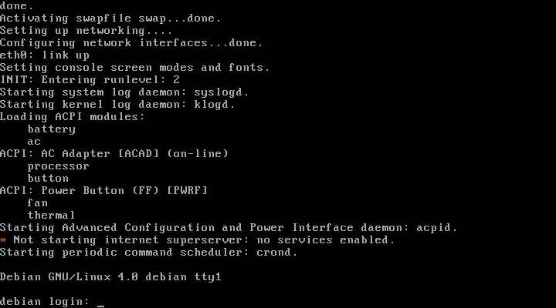
You now have a minimum installation of Debian Linux on the Virtual machine suitable for the Asterisk PBX application.
Don’t forget to backup your installation to a flash drive.
Show this to me.

